Wedding Planners
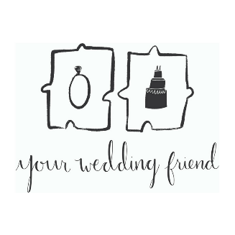

Your Wedding Friend will help you on your perfectly planned wedding preparations, from wedmin to on-the-day set ups and more, we take the pain out of the wedding planning.

Vikki Richman
Your Wedding Friend
07801 328639

www.yourweddingfriend.co.uk
www.facebook.com/YourWeddingFriend
www.instagram.com/yourweddingfrienduk

