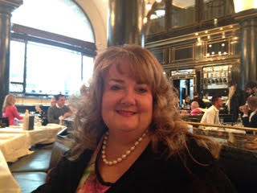
Sandra Louise Lambert
Personal Travel Consultant
Dream Travel Ltd
Explorer Travel Holidays
sandra@explorertravelholidays.co.uk
dreamtrips-explorertravelholidays.co.uk
Mobile: 07949 405015
Business: 01442 46246

As an Independent Personal Travel Consultant I find the perfect holidays worldwide to suit your exact requirements that are ABTA and ATOL protected.

