D.J.’s

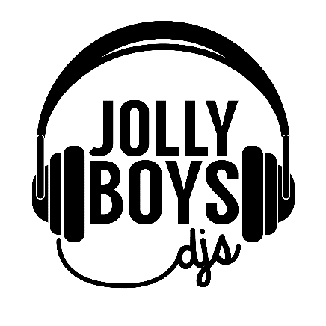
At Jolly Boys DJs, our aim is to offer outstanding entertainment for your weddng day, whilst offering a totally personal service. Each and every couple has a unique taste in music and we like to understand what kind of vibe you want from your night; you may prefer to stick with the party classics of the 80s, or you may love the idea of an Ibiza party vibe! Every client is different and we love to discuss and advise on what will work well for your big day.
From rustic booths to neon signs, dry ice to Love Letters, dancefloors to uplighters – whatever you need we can cater for it! Last year we won the ‘One to Watch’ award at the highly competitive Four Counties Wedding Awards. This year we’ve been raising the bar and working hard to bring more bespoke music mixes and unique added extras to our clients, so that we can offer you the very best for your big day

Contact details: Email info@jollyboysdjs.com,
Call us on 07966974116
Find us on Facebook/Insta @jollyboysdjs

