Photographers

Becky Harley is an award winning photographer based in Hertfordshire. She specialises in capturing bright, natural and relaxed images of light, life and love on your wedding day.
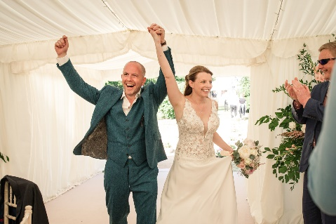
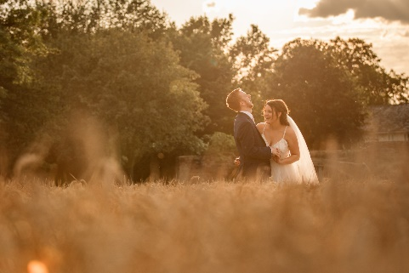
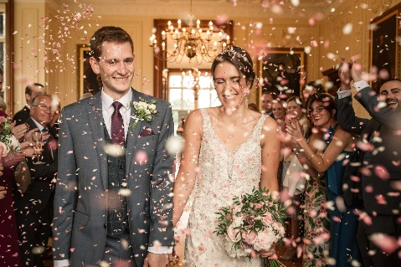

Contact details-
https://www.beckyharleyphtoography.co.uk
hello@beckyharleyphotography.co.uk
Insta - @beckyharleyphotog
FB - /beckyharleyphotography

