Hair & MakeUp
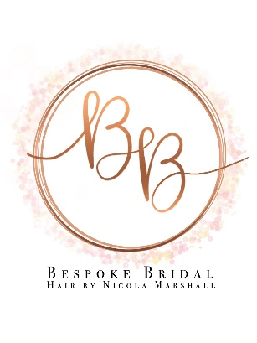

Hi I’m Nicola a Hertfordshire based hairstylist but love to travel all over for weddings, I've been in the industry for over half my life now and am so fortunate to wake up each day and do something I love.
My goal is to make you feel the most beautiful version of yourself on your big day. It is such an honour to be chosen to share a bride's special moments before the start of her married life.
I would best describe my style as romantic, relaxed boho with a touch of sparkle. If this sounds like the theme that's right for your wedding vision, please take a little look to find out more
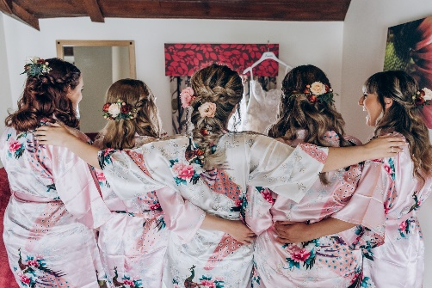
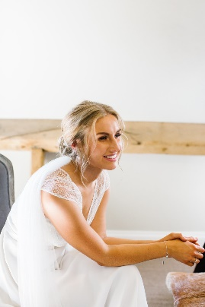
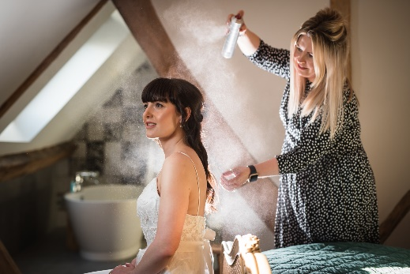

Nicola Marshall
Bespoke Bridal Hair by Nicola Marshall
https://www.bespokebridalhair.co.uk/
bespokebridalhairbynicolamarshall@outlook.com
https://instagram.com/bespokebridal_hairbynicola

