D.J.’s & Live Bands

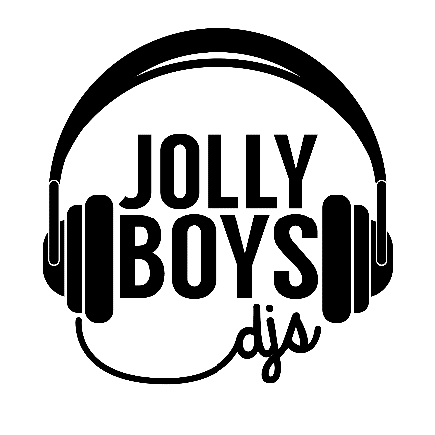
At Jolly Boys DJs, our aim is to offer outstanding entertainment for your weddng day, whilst offering a totally personal service. Each and every couple has a unique taste in music and we like to understand what kind of vibe you want from your night; you may prefer to stick with the party classics of the 80s, or you may love the idea of an Ibiza party vibe! Every client is different and we love to discuss and advise on what will work well for your big day.
From rustic booths to neon signs, dry ice to Love Letters, dancefloors to uplighters – whatever you need we can cater for it! Last year we won the ‘One to Watch’ award at the highly competitive Four Counties Wedding Awards. This year we’ve been raising the bar and working hard to bring more bespoke music mixes and unique added extras to our clients, so that we can offer you the very best for your big day

Contact details: Email info@jollyboysdjs.com,
Call us on 07966974116
Find us on Facebook/Insta @jollyboysdjs

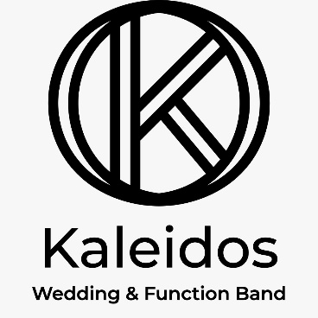
Kaleidos are an independent 4-piece function band based in Beds/Cambs and surrounding areas. With each member coming from a different musical background, they have created a vibrant eclectic sound, which will add a soulful spin to all your favourite songs. For an energetic ‘live-lounge’ party, Kaleidos are the band you need!

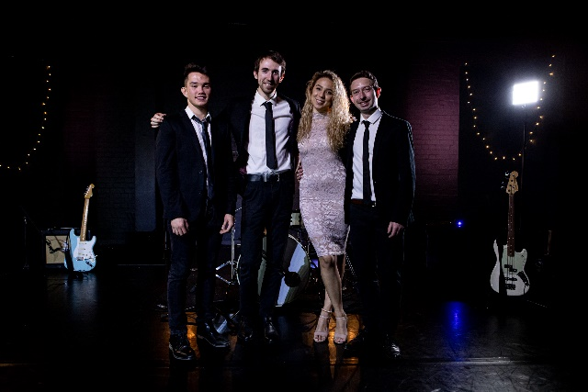

Contact Details:
musicbykaleidos@gmail.com
Facebook.com/MusicByKaleidos
Instagram.com/MusicByKaleidos

J N SOUNDS Wedding and Party DJ

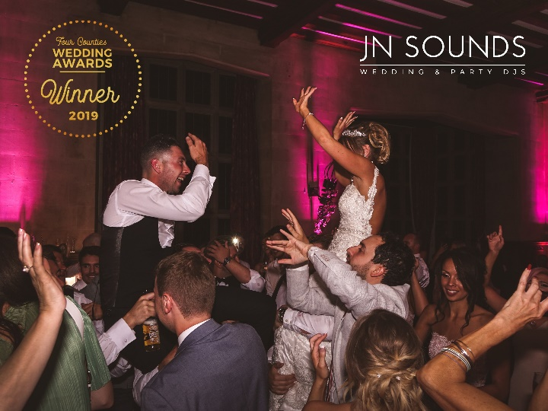
With a modern approach to wedding DJ entertainment, Dan will personalise all aspects of what he does to your tastes. Giving you the party you want and an amazing night to remember.

Whatever the occasion, he'll take you through a simple planning process with ongoing support until the day of your event. With minimal mic chat and club style DJ mixing, it’s Dan's goal to provide a unique,
contemporary wedding reception that you’ll love!

Options include; various DJ booth options, mood lighting, neon signs, DJ and sax, and lots more.

info@jnsounds.com
www.jnsounds.com

